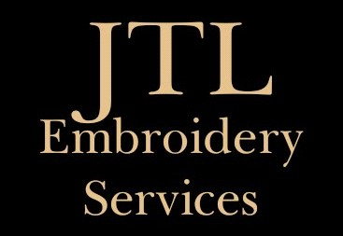

**APPAREL & DESIGN ORDER FORM**

Company Name:

Contact Name:

Contact Email:

Contact Mobile:

PO# (if applicable):

**DESIGN/S REQUIRED**

Is your design digitized? Yes / No

* If yes, do we already hold this on file?
* If no, **please email a pdf format** of your logo to us along with confirmation we are to proceed with digitizing.
* Please note, this is a once off cost of $65 + GST per logo.

|  |  |  |
| --- | --- | --- |
| **Wording/Design** | **Thread Colour** | **Further Details inc positioning, names per size apparel etc.** |
|  |  |  |
|  |  |  |

**APPAREL REQUIRED**

|  |  |  |  |  |  |
| --- | --- | --- | --- | --- | --- |
| **Supplier** | **Code** | **Description inc Colour** | **Size** | **Qty** | **Quote “Q” OR Order “O”** |
|  |  |  |  |  |  |
|  |  |  |  |  |  |
|  |  |  |  |  |  |
|  |  |  |  |  |  |
|  |  |  |  |  |  |

Upon receiving this form, if you have requested a quotation, we will get back to you within 48 business hours noting our working days/times are Mondays, Wednesdays & Fridays – 8:30am – 3:30pm.

**THANK YOU FOR HELPING SUPPORT OUR SMALL BUSINESS.**