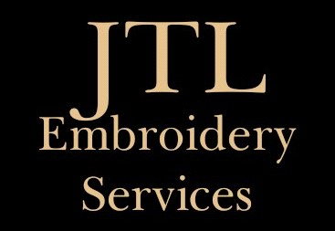

**LEGEND LIFE APPAREL & DESIGN ORDER FORM**

Company Name:

Contact Name:

Contact Email:

Contact Mobile:

PO# (if applicable):

**LEGEND LIFE DESIGN/S REQUIRED**

Is your design digitized for the decoration required? Yes / No

* If yes, do we already hold this on file?
* If no, **please email a pdf format** of your logo to us along with confirmation we are to proceed with digitizing.
* Please note, this is a once off cost of $65 + GST per logo.

|  |  |  |  |
| --- | --- | --- | --- |
| **Wording/Design** | **Thread / Ink Colour** | **Decoration Required** ie  "Supacolour/Screenprinting", "Supaetch", "Supaflex", "Supasub" and/or Embroidery | **Further Details inc positioning, names per size apparel etc.** |
|  |  |  |  |
|  |  |  |  |

**LEGEND LIFE APPAREL REQUIRED**

|  |  |  |  |  |  |
| --- | --- | --- | --- | --- | --- |
| **Code – min 20** | **Description** | **Colour – min 20** | **Size** | **Qty – min 20** | **Quote “Q” OR Order “O”** |
|  |  |  |  |  |  |
|  |  |  |  |  |  |
|  |  |  |  |  |  |
|  |  |  |  |  |  |
|  |  |  |  |  |  |

**THANK YOU FOR HELPING SUPPORT OUR SMALL BUSINESS.**